Central Cal Dirt Dogs Gold Coach Jeff Harger 559.730.6966 www.centralcaldirtdogs.org
 | #1  Sydney White  P / 1B  Class of 2012 – Clovis West  GPA 3.67 SAT 1360  kzspeed@aol.com |  | #2  Hannah Harger  Class of 2012  NEVADA - RENO |  | #2  Katie Robertson  Class of 2013  UC DAVIS
 | #3  Dana Moritz  P / 1B  Class of 2012 – Clovis High  GPA 3.8 SAT 1320  dmmdaisy@msn.com | 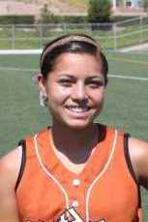 | #5  Demi Balbina  SS / 2B / 3B  Class of 2013 – Hanford West  GPA 3.67 PSAT 126  demilynne_95@hotmail.com | 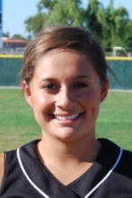 | #5  Karsyn Guzman  SS / OF  Class of 2013  CAL STATE BAKERSFIELD
 | #7  Briana Pontecorvo  Class of 2012  SAN JOSE STATE | 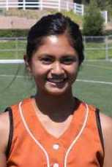 | #8  Jayd Cuaderno  3rd / 1B / OF  Class of 2013 – Clovis North  GPA 3.6 SAT 1290  jaydcuaderno@comcast.net | 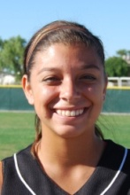 | #9  Kyla Cisneros  1B, OF, Utility  Class of 2012 – El Diamante  GPA 3.83 SAT 1340  muviegoer1@gmail.com
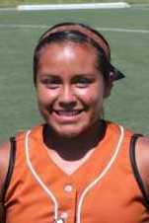 | #9  Hayley Olivas  3B / SS / OF  Class of 2013 – Clovis West  GPA 3.33 SAT  softballjunki9@yahoo.com | 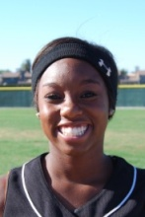 | #10  Bria Kennedy  Class of 2012  FRESNO STATE | 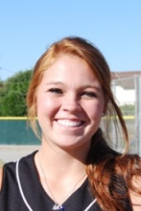 | #11  Amber Mills  Class of 2012  CAL STATE BAKERSFIELD
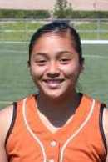 | #13  Alyssa Navarro  2B / 3B / SS / OF  Class of 2013 – Dinuba  GPA 3.0 SAT  Alyssa_navarro13@yahoo.com | 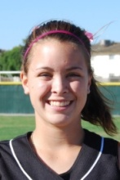 | #15  Jessie Moorhead  Class of 2012  MARION MILITARY ACADEMY | 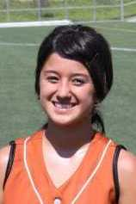 | #27  Carissa McMillon  Pitcher / 2B  Class of 2013 – Madera High  GPA 3.4 SAT  carissa_mcmillon27@yahoo.com
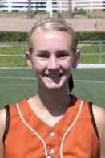 | #00  Danielle Emerson  OF  Class of 2013 – Monache  GPA 4.0 SAT  disneyfreak913@yahoo.com |  | #  Brittany Embry  3B  Class of 2012 – Central High  GPA SAT  Email

Central Cal Dirt Dogs Gold – Uncommitted Players
Dirt Dog is an athletic nickname given to certain players who are "scrappy" or blue-collar, hardworking and tenacious.
# | First | Last | Year | Position |  | Height | B/T | GPA | SAT | Phone |  | Email | Notes
1 | Sydnee | White | 2012 | Pitcher / 1B |  | 5’ 5” | R/R | 3.67 | 1360 | 559.322.8928 |  | kzspeed@aol.com
3 | Dana | Moritz | 2012 | Pitcher / 1B |  | 5’ 8” | L / L | 3.80 | 1320 | 559.301.3792 |  | dmmdaisy@msn.com
5 | Demi | Balbina | 2013 | SS / 2B / 3B |  | 5’ 3” | Slap/R | 3.67 | nyt | 559.362.9679 |  | demilynne_95@hotmail.com
8 | Jayd | Cuaderno | 2013 | 3B / 1B / OF |  | 5’ 7” | R / R | 3.6 | 1290 | 559.907.9830 |  | jaydcuaderno@comcast.net
9 | Kyla | Cisneros | 2012 | 1B/2B/SS/OF |  | 5’ 6” | R / R | 3.83 | 1340 | 559.731.9993 |  | muviegoer1@gmail.com
9 | Hayley | Olivas | 2013 | 3B / SS / OF |  | 4’ 10” | R / R | 3.33 | nyt | 559.281.7031 |  | softballjunki9@yahoo.com
13 | Alyssa | Navarro | 2013 | 2B/3B/SS/OF |  | 5’ 4” | R / R | 3.0 | nyt | 559.393.9862 |  | Alyssa_navarro13@yahoo.com
27 | Carissa | McMillon | 2013 | Pitcher / 2B |  | 5’ 0” | R / R | 3.4 | nyt | 559.871.0375 |  | carissa_mcmillon27@yahoo.com
00 | Danielle | Emerson | 2013 | OF |  | 5’ 8” | R / R | 4.0 | nyt | 559.361.1928 |  | disneyfreak913@yahoo.com
 | Brittany | Embry | 2012 | 3B
Coach Jeff Harger  559.730.6966  jharger223@aol.com |  |  |  |  |  |  |  |  |  |  | www.centralcaldirtdogs.org

